Terms of Reference

Project Details
Project No.

Project Name | Claim Single System
At Gate

Document Signed Off By
Department | Name  Firstname & Surname & Title | Signature | Date
Business  - Project Manager / Business Manager  - Project Sponsor | Project Sponsor  Surasit Ploydanai (COO)
Apirak Chitranondh

Att Ayawongs

IT  - RCIO or delegate | Yodsak Panmanotham (CIO)
IT  - RCIO or delegate | Ongart Roonchai  Suthichai Suwanarat  Phetcharat Boonritrutaikul  Nopparat Siripanich

Document Distribution List
To / CC | Name  Firstname & Surname & Title | Department
To: | Project Manager  Project Team Members  Cholticha Rujiratorn  Wannathi Chansanit  Sarat Sangsurat | Operations  Operations  Operations
CC: | IT Team Members  Banphot Khongpon  Wiboon Oransirikul  Ayuth Sankule | Information Technology  Information Technology  Information Technology

Document Control
Version  Number  n.n | Issued  On Date  YYYY/MM/DD | Author(s)  Firstname & Surname & Title | Reviewer(s)  Firstname & Surname & Title | Change Description
1.0 | 2010/05/01 | Suratsawadee S (BSA) | Phetcharat B. – AVP IT project and Governance | First draft
1.1 | 2010/05/11 | Suratsawadee S (BSA) |  | Add Hardware on Section 7.1
1.2 | 2010/05/13 | Suratsawadee S (BSA) |  | Update estimation effort
1.3 | 2010/05/15 | Suratsawadee S (BSA) |  | Add Type of Coverage Payment on Section 5.1
1.4 | 2010/05/24 | Suratsawadee S (BSA) |  | - Update Type of Coverage Payment on Section 5.1  - Change and amendment on Section 14.2  - Update project schedule, effort on Section 14.3
1.5 | 2010/05/27 | Suratsawadee S (BSA) |  | Add Security Measures on section 8.1.4
1.6 | 2010/06/11 | Natchanun J (BSA) |  | Update in scope, out scope and assumptions section
1.7 | 2010/06/11 | Natchanun J (BSA) |  | Fix wordings for out scope and assumptions section
1.8 | 2010/06/16 | Natchanun J (BSA) |  | Edit detail according to comments from walkthrough session

Table of Contents

1. Context 5
2. Management Summary 5
3. Project IT Components Definition 5
4. Objectives 5
5. Scope 6
5.1. In Scope 6
5.2. Out of Scope 10
5.3. Assumption 11
6. Requirements 11
7. Proposed Solution 12
7.1. Hardware approach 12
7.2. System Approach 12
7.3. Summary of User Requirement 16
7.4. Summary of Estimated Effort 19
8. System Environment Review 20
8.1. Architectural Solution 20
8.1.1. Application Architecture 20
8.1.2. Data Architecture 20
8.1.3. Technical Architecture 20
8.1.4. Security Measures 20
8.1.5. Platform and Technologies 20
8.2. Service Measurements 21
8.2.1 Anticipated Data Volumes 21
8.2.2 Availability & Response Times 21
8.3. Infrastructure 21
8.3.1 Development Environment 21
8.3.2 Test Environment 21
8.3.3 Production Environment 21
9. Backup & Archive Recovery Requirements 21
10. Cost Estimation 21
11. Risk Management 21
12. Measure of Success 21
13. Dependency and Impact of IT Components of Other Projects 22
14. Proposed Project Plan 22
14.1. Organization of IT Work stream 22
14.2. Governance 24
14.3. Schedule 24
15. Communication Plan 25
16. Appendix A – Project IT Components Definition (PD) 26
17. Appendix B – Risk Register 26
18. Appendix C – Communication Plan 26
19. Appendix D – Reference Documents 26

Context
The objective of this TOR is aimed to provide an application to support claim processing. Claim front-end system will help claim admin staff to perform claim capture, enquiry and approval for policy on ACR, TLS, Personal accidental (PA), Group, circle loan and GSB system as long as the scope and features are not duplicated with RTOM project.

This TOR identified the major system requirement and the proposed development schedule to support the Claim Process Improvement.

Management Summary
The estimated IT cost for X3 is 123.0 man-days.
Together with IT effort on X2 (10.0 man-days) is 133.0 man-days. Please refer to Section 7.3 for detail of IT effort estimation
Please note that effort estimation is subjected to a variance of +/-40%. For effort details, please refer to Section 7.4 Summary of Estimated Effort.

Project IT Components Definition
N/A

Objectives
The objectives of this project are to:
- Deliver a new Web-Based application that Centralized Data from various information source for Claim user to handle the processes of claim registering, claims assessment, approval, inquiry, correspondences printing, and cheque / draft requisition through cheque outsource printing system.
- Improve claim process by fastering turn around time and reducing error rate which caused by human error in manual process

Scope

In Scope
- This project will cover source data from
  - Major claim for the following products:
    - Circle Loan
    - GSB
    - Group Term Life
    - Ordinary
      - ACR – All plan
      - RLS – not cover registration and assessment function but able to make some adjustments for SLI, ELI, WP, WPF, WPD, WPDD riders and UL policies (refer to Functionality section)
    - MRTA
      - ACR – All plan
      - RLS – not cover registration and assessment function (refer to Functionality section)
    - PA (501) and PA (503) – Please see detail in the attached file
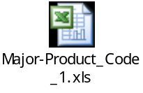
  - Minor claim for the following products:
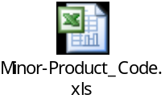

The detail of product codes and claim items are presented in the following table:
Products |  | Plan Code | Claim Item
Major Claim | Circle Loan | G-1060083
Major Claim | GSB | PATMyy/_ _ _ _ _ _  PAMAyy/_ _ _ _ _ _  14001-_ _ _-_ _ _ _ _ _ _ _ _
Major Claim | Group Term Life | 801-_ _ _ _ _ _ _
Major Claim | Ordinary | ACR – All plan  RLS – partial function | e.g. EA60, 25PL, 21AE, 25AE, Term, 20PL, etc.
Major Claim | MRTA | ACR – begin with M  RLS – begin with L, N (partial function) | 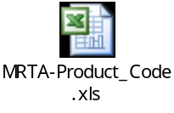
Major Claim | PA (501) | SPA, EPA, GPA | ADB/TPD/ADD, MA, MC
Major Claim | PA (503) | PAC, PAP, PAM | ADB/TPD/ADD, MA, MC
Minor Claim | Accidental Indemnity | ACR – AI | ACR – AI1--N1, AI1-BN1
Minor Claim | Hospital Benefit | ACR – HB | ACR – HB---N1, HB--BN1
Minor Claim | PA (501) | SPA, EPA, GPA | ME, WI
Minor Claim | PA (503) | PAC, PAP, PAM | ME, WI

2. Functionality:
- Claim Registration
  - Capture new major claim data for Circle Loan, GSB, Group Term Life, Ordinary on ACR, MRTA on ACR, PA (501) and PA (503) (product code refer to section 5.1.1 excel files and table)
  - Capture new minor claim data for AI on ACR, HB on ACR, PA (501) and PA (503) (product code refer to section 5.1.1 excel files and table)
  - Automatic download all registered transactions on RLS to Claim Single System every off-line process for adjustment and enquiry
  - Able to make some adjustments for major claim such as overwriting some incorrect values from fault or incomplete calculation on RLS for SLI, ELI, WP, WPF, WPD, WPDD riders and UL policies, which are registered via RLS
  - Able to make some adjustments such as sending letters and printing reports for some pending transactions (a control report for monitoring is required)

  - Claim Assessment
  - Assess claim transactions for in-scope products same as described in claim registration in the above section
  - Automatic download all registered transactions on RLS to Claim Single System every off-line process for adjustment and enquiry
  - Able to make some adjustments for some products same as described in claim registration in the above section
  - Able to make some adjustments for some pending transactions same as described in claim registration in the above section

- Claim Payment
  - Support Cheque/Draft requisition and bank transfer payment
  - Export the claim payment transaction into excel file for Finance only, not automatically upload to KTB Cheque Outsource.

- Claim Letter
  - There’re 8 letters of Major claim and 4 letters of Minor claim
- Claim Report
  - There’re 3 reports
- Claim History Enquiry
- Upload and Review claim data from AXA Assistance
- Claim Cancellation and Reissue new claim number
- Back End System for admin user
- Table Maintenance by users

3. This project will provide claim type and type of insurance as below

Major Claim:
Type of Insurance /  Coverage Payment | Function
Type of Insurance /  Coverage Payment | Registration | Assessment | Payment and Cheque requisition | Report and  Letter | Enquiry | Upload
Circle Loan |  |  |  |  |  | 
GSB |  |  |  |  |  | 
Group Term Life |  |  |  |  |  | 
Ordinary (ACR - 501) –all plan |  |  |  |  |  | 
Ordinary (RLS - 502) | Download data from RLS and  can make some adjustments for some riders – refer to section 5.1.1 |  |  |  |  | 
MRTA | Download data from RLS  – refer to section 5.1.1 |  |  |  |  | 
PA (501)  - ADB/ TPD/ ADD  (Accidental Death and Disability)  - MA (Murder assault)  - MC (Motorcycle) |  |  |  |  |  | 
PA (503)  -ADB/ TPD/ ADD  (Accidental Death and Disability)  -MA (Murder assault)  -MC (Motorcycle) |  |  |  |  |  | 

Minor Claim:
Type of Insurance /Coverage Payment | Function
Type of Insurance /Coverage Payment | Registration | Assessment | Payment and Cheque requisition | Report and  Letter | Enquiry | Upload
Accidental Indemnity Rider  - AI (ACR) |  |  |  |  |  | 
Hospital Benefit  - HB (ACR) |  |  |  |  |  | 
PA (501)  - ME (Medical Expense)  - WI (Weekly Indemnity) |  |  |  |  |  | 
PA (503)  - ME (Medical Expense)  - WI (Weekly Indemnity) |  |  |  |  |  | 

4. This project will provide claim letter and Cheque/Draft requisition as shown below

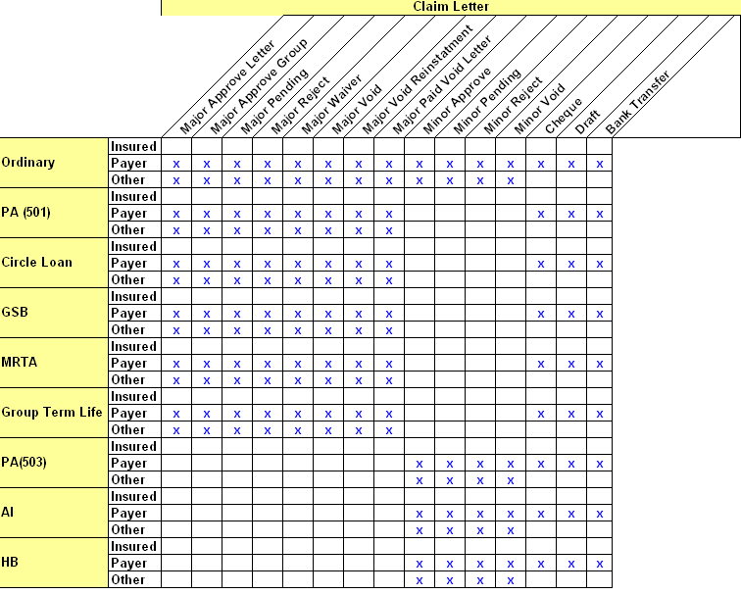

Out of Scope
- System will not support the enquiry single view of customer.
- System will not support data upload back to Host System (RLS, ACR, Circle Loan, GSB, Group Term Life and PA)
- System will not support register and assess major claim for products, which are able to perform on RLS, somehow system will support some adjustments for only the SLI, ELI, WP, WPF, WPD, WPDD riders and UL policies.

- System will not support register and assess minor claim for all products, which are able to perform on RLS
- System will not support claim transaction for products which are performed by AXA Assistance
- System will not support online calculation fields from ACR, RLS and RCMS ( e.g. Loan, Loan Interest, Cash Value, Dividend, Policy fund, ETI and RPU)
- System will not support data conversion in this phase
- System will not support fully automatic assessment
- System will support only partial validation or business rule.
- System will not cover any fix or enhance core systems that will impact or imply any change to this claim system development; change request is needed.
- There is no system interface with any core systems

Assumption
- Claim database will be updated data from host system on daily process (from CDB minus 1 day behind production).
- There is no system enhancement on the existing RLS, ACR, and Cheque outsources system during claim system development.
- System is developed base on Web application.
- Claim registration
  - System will obtain policy information from host system based on the input policy number
  - System will provide a drop down list for impairment code
- Claim assessment
  - System will calculate claim payment base on the provided formula
  - User manually verify and assess the claim request before making a decision whether to approve or reject the request
- Claim payment
  - Cheque requisition
    - System allows users to choose payment transaction to be generated in excel file for manual upload to Cheque outsource payment.
  - Cheque reconciliation
- User is able to import the Cheque payment result (e.g. cheque no., payment date) back to the claim front-end system for further inquiry and tracking
  - User is able to choose bank transfer payment method

Requirements
For details of business requirements, please see the attached Business Requirement Specifications.
Business Requirement Specification
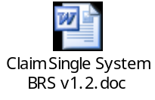

Proposed Solution

Hardware approach
- Web Application:
IIS 6 – Intranet05
SQL Server 2005 – KTALDB2
Windows Server 2003
- Development Tool:
Visual Studio 2008
DevExpress Web Component V.9.2.4
.NET Framework 3.5 SP 1
- Reporting Tool:
Microsoft Office V.2003

Note: There is no additional hardware cost.

System Approach

7.2.1 Single claim database
- Creating a new database for Claim Front End System that extract data from AS/400, RLS, ACR, Circle Loan, GSB and PA systems
- Provide upload function to support Group Term Life policies which currently stored in Excel worksheet.
7.2.2 Claim Registration
Create a function to
- Capture new claim transaction of ACR, Circle Loan, GSB, Group Term Life and PA. System will show policy information according to the policy number that was input by the user such as Insured name, surname, basic plan, rider plan, Sum insured and coverage detail.
- Support Major Claims for below product
- Ordinary
- PA (501)
- Circle Loan
- GSB
- MRTA
- Group Term Life
- PA (503)
- Support Minor Claims for below product
- AI
- HB
- PA (501)
- PA (503)
- Support claim payment for both beneficiary and non-beneficiary.
    - Claim Assessment
- Support search function for captured claim transaction by policy number, Citizen ID, Claim number, Insured name and insured surname.
- Support search edit function to update previous captured claim transaction
- Support claim payment calculation function with calculate claim payment and total payment base on each Claim type.
- Support claim approval function
There’re 7 types of Major claim decision subject to type of basic plan.

Type of Insurance | Decision
Ordinary | Approve
Ordinary | Pending
Ordinary | Void
Ordinary | Void-Rein
Ordinary | Deny
Ordinary | Paid-Void
PA (501) | Approve
PA (501) | Pending
PA (501) | Void
PA (501) | Deny
Circle Loan | Approve
Circle Loan | Pending
Circle Loan | Void
Circle Loan | Paid-Void
Circle Loan | Deny
MRTA | Approve
MRTA | Pending
MRTA | Void
MRTA | Deny
GSB | Approve
GSB | Pending
GSB | Deny
Group Term Life | Approve
Group Term Life | Pending
Group Term Life | Void
Group Term Life | Deny
PA (503) | Approve
PA (503) | Pending
PA (503) | Void
PA (503) | Deny

There’re 4 types of Minor claim decision subject to rider plan.

Type of Insurance | Decision
AI | Approve
AI | Pending
AI | Void
AI | Deny
HB | Approve
HB | Pending
HB | Void
HB | Deny
PA (501) | Approve
PA (501) | Pending
PA (501) | Void
PA (501) | Deny
PA (503) | Approve
PA (503) | Pending
PA (503) | Void
PA (503) | Deny

- Support Batch printing process for correspondences.
There’re 2 types of Major and Minor claim letter as below.

Major Claim Letter | Minor Claim Letter
- Major Approve Letter | Minor Approve Letter
- Major Approve Letter Group | Minor Pending Letter
- Major Pending Letter | Minor Reject Letter
- Major Reject Letter | Minor Void Letter
- Major Waiver Letter
- Major Void Letter
- Major Void Rein Letter
- Major Paid Void Letter

    - Claim Payment
- Support search function for previous payment transaction by policy number, Payee type, Insured name and Insured surname, Payee name and Payee surname, Decision date (range), Type of Decision, Batch number and Account no.
- Support payment type by Cheque, Draft and Bank Transfer.
- Support multiple selection payment transaction with check box.
- Support interface excel file with Cheque outsource system.
- Support Cheque and Draft payment resulted update through excel file from Cheque Outsource system.
- Support payment report and printing detail result in excel file format.

    - Claim inquiry
      - In process transaction
- Search function for in process claim transaction by policy number., Payee type, Type of Decision, Decision date(range), Insured name and Insured surname, Payee name and Payee surname, workflow status and batch number.
- System will retrieve correct information according to the provided search criteria.
      - Claim History inquiry
- Search claim history by policy number.

    - AXA Assistance inquiry
- Support upload function store Claim data from AXA Assistance on claim front end system database.
- Support AXA Assistance claim inquiry through policy search

    - Claim report

Report Name | Frequency | Output
Actuarial report | Monthly | Excel
Pending Major claims report | Daily | Excel
Pending Minor claims report | Daily | Excel

    - Claim Cancellation and Reissue new claim number
- Support search function for existing claim transaction by policy number, Payee type, Type of Decision, Decision date (range), Insured name and Insured surname, Payee name and Payee surname.
- All claim data will step backward as a new transaction.
- Allow authorized person to reverse claim transaction only.

    - Back End Function
- User Management and Add / Delete / Remove user
- Authentication with Active Directory user
- Security transaction log to log all transaction activities that related to information capture, edit, reverse and delete.

    - Table Maintenances
- OIC table
- Province table
- ICD10 Code

Summary of User Requirement

User Requirement  (for details, please refer to the BRS) | Proposal  Approach  Description | Priority/ Impact | Estimated Effort (Man-Day)
• Claim Registration | Create a function and screen to registration new claim transaction separate to Major claim and Minor claim | H | 3
• Claim Registration | Coding retrieved customer data from host system process | H | 5
• Claim Registration | Coding get document data from submission center process (call SMC Web service) | H | 1
• Claim Registration | Coding search the registration transaction screen (New Inbox) | H | 2
• Claim Assessment | Coding Assessment Screen | H | 3
• Claim Assessment | Coding Assessment WIP Inbox | H | 2
• Claim Assessment | Coding generate Major claim letter  ( 7 template separate by decision) | H | 4
• Claim Assessment | Coding generate Minor claim letter  (4 template separate by decision) | H | 2
• Claim Assessment | Coding generate Batch no | H | 1
• Claim Assessment | Coding payment calculation process | H | 1
• Claim Payment | Coding Cheque and Draft Request Inbox | H | 1
• Claim Payment | Coding Generate Cheque /draft requisition to excel format | H | 2
• Claim Payment | Design of the interface excel file with Cheque outsource system | H | 2
• Claim Payment | Coding Cheque/Draft Receipt | H | 1
• Claim Payment | Coding Print out Letter Inbox screen | H | 1
• Claim Payment | Coding generating letter as MS-word document | H | 1
• Claim Payment | Coding mail out inbox screen | H | 1
• Claim Payment | Design and coding the screen for payment report and printing detail result in excel file format | H | 2
• Claim Payment | Design and coding the screen for payment report and printing detail result in excel file format | H | 2
• Search | Coding search claim information screen | H | 2
• View Claim History | Coding view claim history screen | H | 2
• Upload and Review claim data from AXA Assistance | Coding upload screen | H | 1
• Upload and Review claim data from AXA Assistance | Coding import AXA assistance process | H | 4
• Upload and Review claim data from AXA Assistance | Coding search AXA assistance data screen | H | 1
• Generated claim Report | Coding view actuarial report screen | H | 1
• Generated claim Report | Coding Generate actuarial report to excel format | H | 1
• Generated claim Report | Coding view pending report screen | H | 1
• Generated claim Report | Coding Generate pending report to excel format | H | 2
• Reversal Claim transaction | Coding Reverse screen | H | 2
• Back End | Coding authentication user function(with Active Directory ) | H | 1
• Back End | Coding user authorization management screen | H | 2
• Table Maintenances | Same as normal setting, which are  - OIC table  - Province table  - ICD10 Code | H | 1

Summary of Estimated Effort

System / Module / Function | Effort (man-day)
Analysis | 8.0
Design | 3.0
Development  - Download files from Host system to SQL  - Build database structure on SQL  - User Management and authentication  - Claim registration Module  - Claim Assessment Module  - Claim Payment Module  - Search  - View Claim History  - Upload and Review Claim Data from AXA Assistance  - Generate Claim Report  - Reverse Module  - Table Maintenances | 66.0  3  5  3  11  13  13  2  2  6  5  2  1
System Test | 10.0
UAT Support | 13.0
Implementation | 3.0
Management 10% of develop effort | 9.0
Subtotal | 112.0
Contingency (10%)* | 11.0
Total X3 | 123.0
Feasibility Effort of X2 | 10.0
Total X2 | 10.0
Grand Total (X2 + X3) | 133.0

System Environment Review

Architectural Solution

Application Architecture
Web application
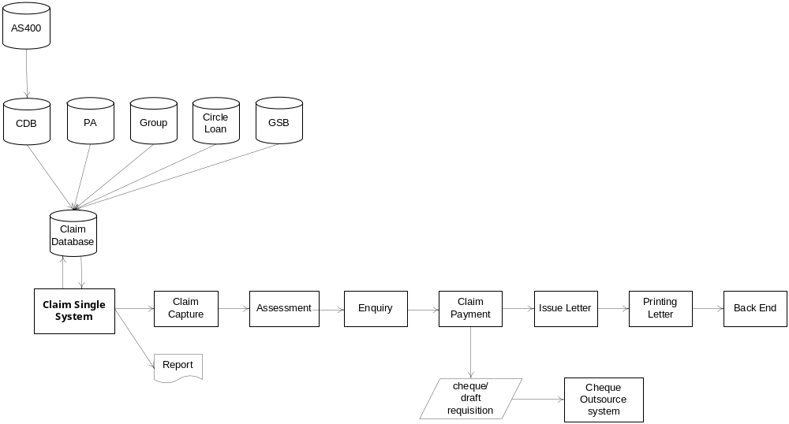

Data Architecture
MS SQL Server 2005

Technical Architecture
N/A

Security Measures
- Application Security Standard V.1.0
- Group Information Security V.13.0

Platform and Technologies
The application system is built on Web Application server.

Service Measurements

8.2.1 Anticipated Data Volumes
N/A

8.2.2 Availability & Response Times
N/A

Infrastructure

8.3.1 Development Environment
Development environment will be located at KAL site.

8.3.2 Test Environment
Test environment will be located at KAL site.

8.3.3 Production Environment
After UAT is done, Test Environment will be promoted to Production Environment.

Backup & Archive Recovery Requirements
Depending on Business Impact Assessment done by user, backup may be required.

Cost Estimation
Costs figures should be presented in local currency, AUD and USD, detailing the cost by type.
(‘000’) | X0 | X1 | X2 | X3 | Total
Cost (THB) | N/A | 0.00 | 0.00 | 0.00 | 0.00
Cost (AUD)
Cost (USD)
Sensitivity Range* | +/-??% | +/-??% | +/-??% | +/-??% | +/-??%
Note: Not applicable for actual costs incurred in previous gate(s).

Risk Management
Please refer to Appendix B for detail of risk register.

Measure of Success
This new Web base Claim Single System should be delivered within defined scope, quality, delivery, and cost.
Critical Success Factor
  - No change on IT project prioritization
  - Sufficient IT resource
  - No change in business requirement after project commencing
  - Full user commitment on UAT

Dependency and Impact of IT Components of Other Projects
    - Resources allocated to this project to meet the tight timeline would affect the delivery of other in-flight projects.
    - RTOM Local System Integration
    - RTOM R023, R024 and New product

Proposed Project Plan

Organization of IT Work stream

The roles and responsibilities of key stakeholders are included in the following table.

Role | Name | Responsibility
Steering Committee | Michael G P.  David K.  Roger D.  Surasit P.  Yodsak P. | - Assure availability of essential project resources  - Assure the project team in overcoming project  obstacles  - Maintain the priority of the project relative to other competing projects
Project Sponsor | Surasit P. | - Define project scope and validate the deliverables  - Approve significant project changes  - Assist the project team in overcoming project  obstacles
Project Manager  Business Quality | Apisara L. | - Define scope and requirement for the project  - Assist and support UAT lead and complete UAT Test Plan and Test case
Project Manager  Business System Analyst | Suratsawadee S. | - Define scope and requirements of the IT components according to the agreed business requirements of the project  - Overall project management and co-ordinate all related internal and external parties (if any) of all project tasks  - Coordinate IT project activities and manage the scope, monitor progress of the project, and ensure agreed milestones are met  - Communicate to stakeholder the project progress at the regular – Responsible for communicate plan, report, progress to project team and Steering Committee  - Ensure that the project is completed on time and within the project constraints
Project team member | Cholticha R.  Wannathi C.  Sarat S. | - Subject Matter Expert to Confirm Business requirements.  - Assist and support in the project development as a subject matter experts to confirm business requirements and to identify the project risk  - Lead and Conduct the UAT – check the final output on agreed template against AS400
Developer | Assawin C. | - Responsible for system development, unit and system testing, UAT Support and implementing the project.
Supervisor | Banphot K. | - Responsible for detailed study, review coding and testing result, UAT Support and implementation preparation.
Quality Assurance Group (IT process improvement) | Phetcharat B.  Ongart R.  Nopparat S.  Suthichai S. | - Review document such as TOR, FS, TS, SIT Plan, UAT Plan, and implementation preparation.  - Review the process and progress of the project.  - Ensure that project was following the SDLC methodologies.

Governance
Change Request Handling
1. Change request identified by any parties must be documented on the change request form and send to IT for impact analysis, cost evaluation and risk assessment.
2. Assessed change request will be sent to the project sponsor and business project manager to decide whether it is approved. Moreover, it is also subject to their decision to submit to senior management for their approval and consideration the impact to business.
3. Project plan, study report, system specification, program specification and test plan must be revised to reflect the change and communicated to both business and IT affected groups after the change request is approved.
4. If the change request is disapproved, the change request should also be recorded in the change request list with status disapproved.
5. Change request will be tracked to closure by attaching the change request list to the project planning document and weekly progress report (for IT internal use)

Schedule
Milestones | Effort (man-day) | Timelines
Milestones | Effort (man-day) | Start | Finish
BRS Submission (Sing-off) | 25 | 4/3/2010 | 29/3/2010
TOR Development | 21 | 13/5/2010 | 11/6/2010
TOR Review and Sign-off | 8 | 14/6/2010 | 23/6/2010
FS and TS development | 10 | 24/6/2010 | 7/7/2010
Issue FS and TS to user | 2 | 8/7/2010 | 9/7/2010
FS Sign-off by user | 2 | 12/7/2010 | 13/7/2010
TS Sign-off by ITMT | 2 | 14/7/2010 | 15/7/2010
Development | 66 | 26/5/2010 | 31/8/2010
UAT Plan preparation | 10 | 16/8/2010 | 27/8/2010
UAT test case submission | 3 | 30/8/2010 | 1/9/2010
System Testing | 5 | 1/9/2010 | 7/9/2010
UAT | 10 | 8/9/2010 | 21/9/2010
UAT Sign-off | 2 | 22/9/2010 | 23/9/2010
H/W & S/W acquisition | 2 | 24/9/2010 | 27/9/2010
Implementation preparation | 3 | 28/9/2010 | 30/9/2010
Go Live | 1 | 1/10/2010 | 1/10/2010

Communication Plan
See Appendix C.

Appendix A – Project IT Components Definition (PD)
N/A

Appendix B – Risk Register
N/A

Appendix C – Communication Plan
Communication  Description | Frequency | Topics/  Agenda Items | Methods for  Communications | Attendees | Recipients of Reporting
Project Progress | Weekly | Overall project progress | E-mail | Team members | Team members
Project Cost | Monthly | IT cost incurred | E-mail | Project Sponsor and Project Manager | Project Sponsor,  Project Manager,  Yodsak P.

Appendix D – Reference Documents
N/A

